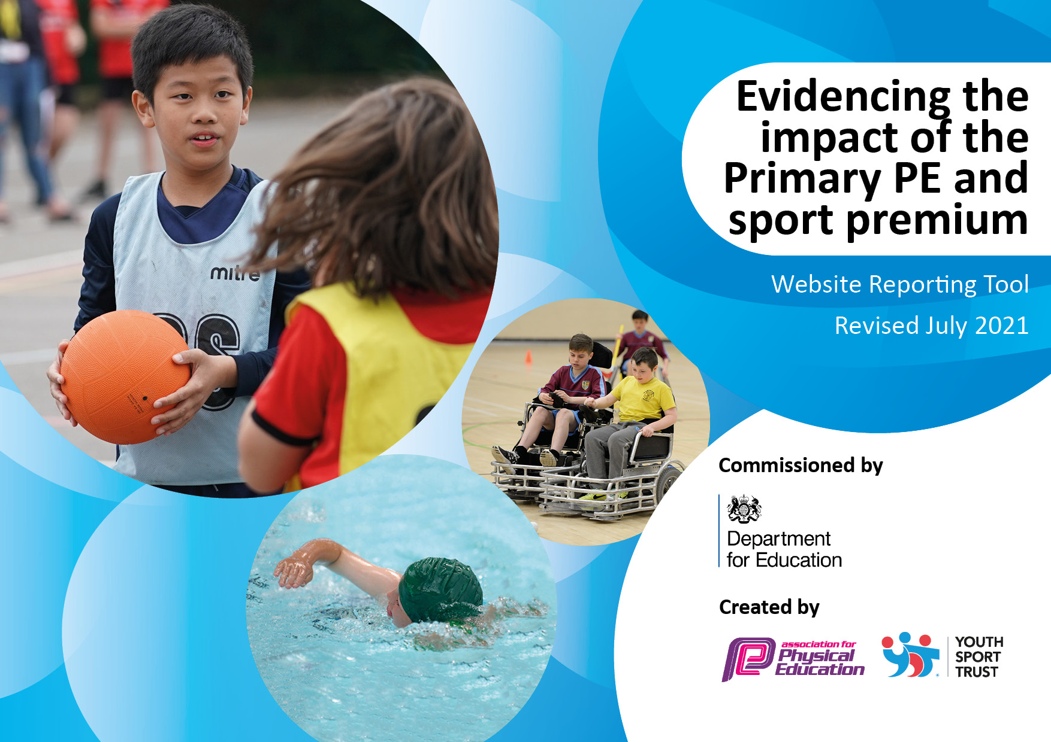
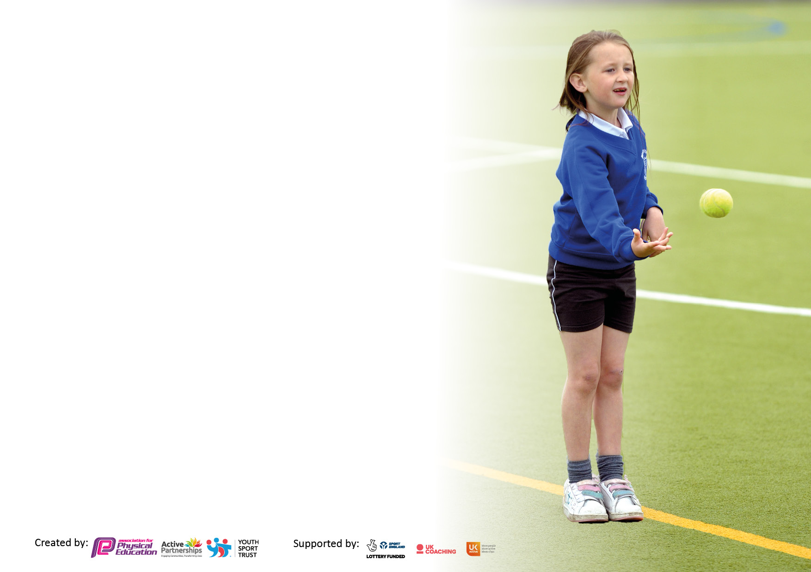

It is important that your grant is used effectively and based on school need. The Education Inspection Framework makes clear there will be a focus on ‘whether leaders and those responsible for governors all understand their respective roles and perform these in a way that enhances the effectiveness of the school’.

Under the Quality of Education Ofsted inspectors consider:
Intent - Curriculum design, coverage and appropriateness
Implementation - Curriculum delivery, Teaching (pedagogy) and Assessment
Impact - Attainment and progress

To assist schools with common transferable language this template has been developed to utilise the same three headings which should make your plans easily transferable between working documents.

Schools must use the funding to make additional and sustainable improvements to the quality of Physical Education, School Sport and Physical Activity (PESSPA) they offer. This means that you should use the Primary PE and sport premium to:

- Develop or add to the PESSPA activities that your school already offer
- Build capacity and capability within the school to ensure that improvements made now will benefit pupils joining the school in future years
- The Primary PE and sport premium should not be used to fund capital spend projects; the school’s budget should fund these.

Pleasevisitgov.ukfortherevisedDfEguidanceincludingthe5keyindicatorsacrosswhichschoolsshoulddemonstrate animprovement.Thisdocumentwillhelpyoutoreviewyourprovisionandtoreportyourspend.DfEencouragesschools to use this template as an effective way of meeting the reporting requirements of the Primary PE and sport premium.

We recommend you start by reflecting on the impact of current provision and reviewing the previous spend.

Schools are required to publish details of how they spend this funding, including any under-spend from 2019/2020, as well as on the impact it has on pupils’ PE and sport participation and attainment. All funding must be spent by 31st July 2022.

We recommend regularly updating the table and publishing it on your website throughout the year. This evidences your ongoing self-evaluation of how you are using the funding to secure maximum, sustainable impact. Final copy must be posted on your website by the end of the academic year and no later than the 31st July 2021. To see an example of how to complete the table please click HERE.

Details with regard to funding
Please complete the table below.

Total amount carried over from 2019/20 | £0
Total amount allocated for 2020/21 | £17340
How much (if any) do you intend to carry over from this total fund into 2021/22? | £0
Total amount allocated for 2021/22 | £17340
Total amount of funding for 2021/22. To be spent and reported on by 31st July 2022. | £17340
Swimming Data
Please report on your Swimming Data below.

Meeting national curriculum requirements for swimming and water safety.  N.B. Complete this section to your best ability. For example you might have practised safe self-rescue techniques on dry land which you can then transfer to the pool when school swimming restarts.  Due to exceptional circumstances priority should be given to ensuring that pupils can perform safe self rescue even if they do not fully meet the first two requirements of the NC programme of study | N/A Covid restricted
What percentage of your current Year 6 cohort swim competently, confidently and proficiently over a distance of at least 25 metres?  N.B. Even though your pupils may swim in another year please report on their attainment on leaving primary school at the end of the summer term 2020.  Please see note above | N/A Covid restricted
What percentage of your current Year 6 cohort use a range of strokes effectively [for example, front crawl, backstroke and breaststroke]?  Please see note above | N/A Covid restricted
What percentage of your current Year 6 cohort perform safe self-rescue in different water-based situations? | N/A Covid restricted
Schools can choose to use the Primary PE and sport premium to provide additional provision for swimming but this must be for activity over and above the national curriculum requirements. Have you used it in this way? | Yes/No

Action Plan and Budget Tracking
Capture your intended annual spend against the 5 key indicators. Clarify the success criteria and evidence of impact that you intend to measure to evaluate for pupils today and for the future.

Academic Year: 2021.22 | Total fund allocated: 17,340 | Date Updated: 13/10/2021
Key indicator 1: The engagement of all pupils in regular physical activity – Chief Medical Officers guidelines recommend that primary school pupils undertake at least 30 minutes of physical activity a day in school |  |  |  | Percentage of total allocation:
 |  |  |  | %30
Intent | Implementation |  | Impact
Your school focus should be clear what you want the pupils to know and be able to do and about  what they need to learn and to  consolidate through practice: | Make sure your actions to achieve are linked to your intentions: | Funding allocated: | Evidence of impact: what do pupils now know and what can they now do? What has changed?: | Sustainability and suggested next steps:
To increase staff confidence in the delivery of PE/PA.  To increase staff’s knowledge to enable them to deliver cross-curricular PE/PA in maths/literacy etc.  To increase staff confidence in the delivery of Outdoor learning .  Introduce ‘Golden Mile’ into a daily routine (across school)  To increase pupil participation in after school clubs and inter-school competitions. | - Purchase PE Programme  - Carry out staff training , after school, session for Teachers on ACE curriculum  - Training for PE lead to enable them to work with staff 1:1 to implement the ACE PE curriculum  - Training for staff so they are equipped to implement Outdoor learning  - 1:1 Professional development sessions for teachers on outdoor learning  - 4 x Staff Meetings Outdoor learning with DET  - Train staff to deliver alternative sports/activities  - Review of After School clubs and pupils daily physical activity (e.g. participation registers, curriculum timetable, 2hrs PE, sports leaders/active playtimes –  - Audit pupil participation (registers and pupil voice)and identify gaps (gender, key stage, year groups) and any barriers to taking part (child care, accessibility, confidence, interest) | 3,000
Key indicator 2: The profile of PESSPA being raised across the school as a tool for whole school improvement |  |  |  | Percentage of total allocation:
 |  |  |  | %
Intent | Implementation |  | Impact
Your school focus should be clear what you want the pupils to know and be able to do and about  what they need to learn and to  consolidate through practice: | Make sure your actions to achieve are linked to your intentions: | Funding allocated: | Evidence of impact: what do pupils now know and what can they now do? What has changed?: | Sustainability and suggested next steps:
To raise the profile of PESSPA within school, recognising whole child development through effective and high quality PESSPA  To recognise PESSPA supporting whole child development and academic success | - Celebration assemblies and award  Ceremonies (Sports person of the week)  - Pupils taking part in intensive small sized PE interventions in the morning  - Leadership opportunities (Sports  Leaders, PE helpers)  - Gifted a Talented PE register to be  introduced to show Multi Abilities  (creative, social, physical,  independent, cognitive) recognition  for support/challenge/enrichment  New Sports Crew trained (running golden time activities, active play etc )  Pupil Trackers - indicating attendance at inter/intra school competition - 1 hour free after school club ‘golden ticket’ for every pupil. | £5500

Key indicator 3: Increased confidence, knowledge and skills of all staff in teaching PE and sport |  |  |  | Percentage of total allocation:
 |  |  |  | %
Intent | Implementation |  | Impact
Your school focus should be clear | Make sure your actions to | Funding | Evidence of impact: what do | Sustainability and suggested
what you want the pupils to know | achieve are linked to your | allocated: | pupils now know and what | next steps:
and be able to do and about | intentions: |  | can they now do? What has
what they need to learn and to |  |  | changed?:
consolidate through practice:
Improve high quality PE provision across whole school (subject knowledge, pedagogy, cross curr links, whole school dev focus etc)  To create a focus upon ‘Food Education’ strand in PE across whole school curriculum to support children’s understanding of the importance of healthy eating. | - Upskilling of staff through ACE PE School Improvement Group: ACE TIGS  - (CPD element include x6 bespoke cluster CPD that includes core curriculum areas, G&T, inclusion/differentiation etc),  - x3 Subject Leader CPD including strategic planning & subject moderation  - x3 Moderation visits from PE TIG  - Staff CPD on how to implement Food Education  - Pupils develop healthy menu for school lunches  - Pupils partake in supporting the community with healthy meals guidance and PA | £3,500
Key indicator 4: Broader experience of a range of sports and activities offered to all pupils |  |  |  | Percentage of total allocation:
Intent | Implementation |  | Impact
Your school focus should be clear | Make sure your actions to | Funding | Evidence of impact: what do | Sustainability and suggested
what you want the pupils to know | achieve are linked to your | allocated: | pupils now know and what | next steps:
and be able to do and about | intentions: |  | can they now do? What has
what they need to learn and to |  |  | changed?:
consolidate through practice:
To provide a broad opportunity for  pupil participation in alternative  activities  To identify talent pathways | - Outdoor learning and growing  - Pupil Voice: Questionnaires and Pupil Leadership Team reviewing after school clubs/opinions/evaluations  see points  - in key indicator 1 SSC trained and supporting pupils to access other activities e.g. forest trail, golden time, active playtime  - Activity/Taster days/events e.g.  - Links to community clubs from above | £2500

Key indicator 5: Increased participation in competitive sport |  |  |  | Percentage of total allocation:
 |  |  |  | %
Intent | Implementation |  | Impact
Your school focus should be clear | Make sure your actions to | Funding | Evidence of impact: what do | Sustainability and suggested
what you want the pupils to know | achieve are linked to your | allocated: | pupils now know and what | next steps:
and be able to do and about | intentions: |  | can they now do? What has
what they need to learn and to |  |  | changed?:
consolidate through practice:
To increase and monitor the  participation of pupils across school  in intra school competition  To increase the number of pupils in  participating in inter school  competition | - Audit current provision of ‘intra’ competition through planning scrutiny i.e staff understanding of ‘competition’ as a learning platform embedded approach to ‘competition’  - pupils setting personal ‘next step’ challenge/target, embedded team paired/small group/team competition in lesson structures.  - Level 1 Intra festivals e.g. end of unit class festival/competition/tournament  - Summer School Sports Day - Intra-House Games / team wear - Dance festival/Assembly showcase year across KS1/2  - Level 2 School Sport Games Competition  - Level 3 County Sports (cros country,athletics, summer games) | £2500

Signed off by
Head Teacher: | William Jaworski
Date: | 13.10.21
Subject Leader: | Jamie McInnes
Date: | 13.10.21
Governor: | Philip Mantell
Date: | 13.10.21

